Idiots Guide to Installing VASPKIT and qvasp

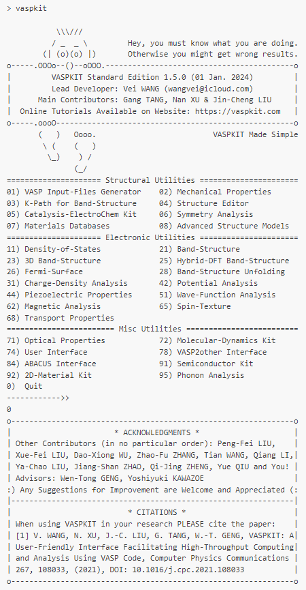 |   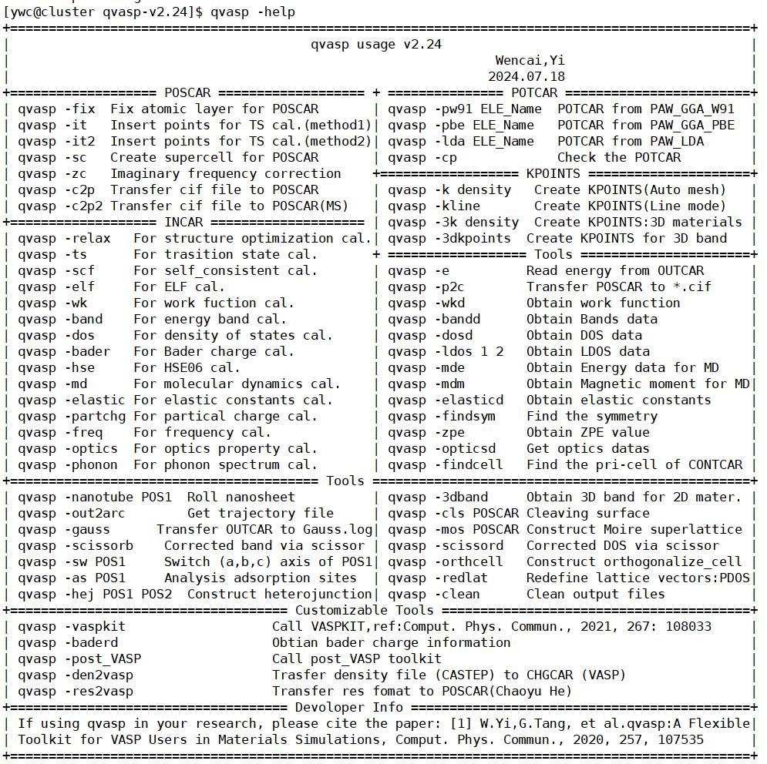
https://vaspkit.com/ | https://sourceforge.net/projects/qvasp/

Guide By: Dr LM Botha.

VASPKIT

A powerful and user-friendly interface to perform high throughput analysis of various material properties from the raw calculated data using the widely-used VASP code. The program can be conveniently run under either the interactive user interface or command line mode.

Step 1:
Download the latest version of vaspkit at the sourceforce website:
https://sourceforge.net/projects/vaspkit/files/Binaries/

Step 2:
Copy the file to your assigned HPC folder, please make sure it is in your home directory and not on the lustre or it can be removed by the administrators such as the monthly data cleanup.

For instance: “/home/username/codes/vaspkit.1.5.1/”

Step 3:
Unzip the folder. In the unix code the command used to unzip tarfiles is tar -xvzf filename.tar.gz
The unzipped folder will now appear in the appropriate folder.

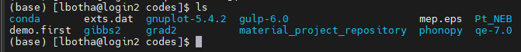
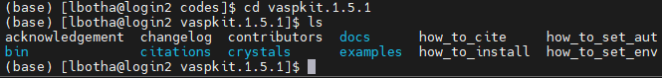

Step 4:
Now you just have the add the paths for the necessary software packages to your vaspkit script which is located at “/home/lbotha/codes/vaspkit.1.5.1/bin”.

Access the folder using the following command:

(base) [lbotha@login2 bin]$ nano ~/.vaspkit

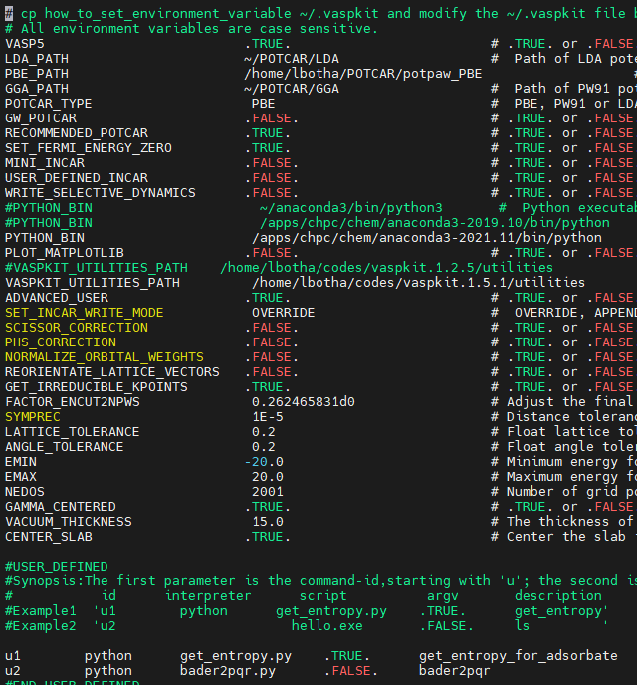

You have to add a few paths for the software to work properly.
- The LDA, PBE and GGA paths to the correct folder in your cluster.
- The path to where python is installed.
- The path to where vaspkit was extracted in your cluster.
- If it does not work then you need to edit the bashrc file (nano ~/.bashrc) and add the path: “export PATH=/home/lbotha/codes/vaspkit.1.5.1/bin:${PATH}”

qvasp

qvasp is a material high-throughput design software based on the VASP package, which mainly includes two functions:
- Realizing high-throughput screening of materials, qvasp program not only can realize high-throughput material structure model constructing, but also provide high-throughput raw data postprocessing toolkits.
- Assisting users to easily generate input files and process output files, realizing rapid conversion between graphics and code, and improving work efficiency.

Step 1:
Download from https://sourceforge.net/projects/qvasp/

Step 2:
As with the VASPKIT, copy the downloaded file and unzip at the correct path.

Step 3:

Install the file:
- Use the command "sh install.sh" to install it.
- OR add the follow lines in your environment variable(such as .bashrc or /etc/profile)

Such as:
export qvasppath=/export/apps/qvasp ## modify it as the path in your servers
export PATH=$qvasppath:$PATH
export PATH=$qvasppath/exefile/Tools/USERTooLs/vtstscripts:$PATH

Step 4:

- You can add the vtstscripts which is downloaded from:
(http://theory.cm.utexas.edu/vtsttools/scripts.html)
- Then exact in $qvasppath/exefile/Tools/USERTooLs/vtstscripts

